Adding/Editing a DNA Sequence on an iNaturalist observation
Anyone can add a DNA sequence to any iNaturalist observation.
Anyone can edit the DNA sequence present in any iNaturalist observation.
Only the owner of an observation can delete a DNA sequence field.
Only one ITS DNA sequence per observation.
To add a new DNA sequence to an observation:
- Open the observation and scroll down to “Observation Fields” section and start typing “DNA Barcode” in the text box.
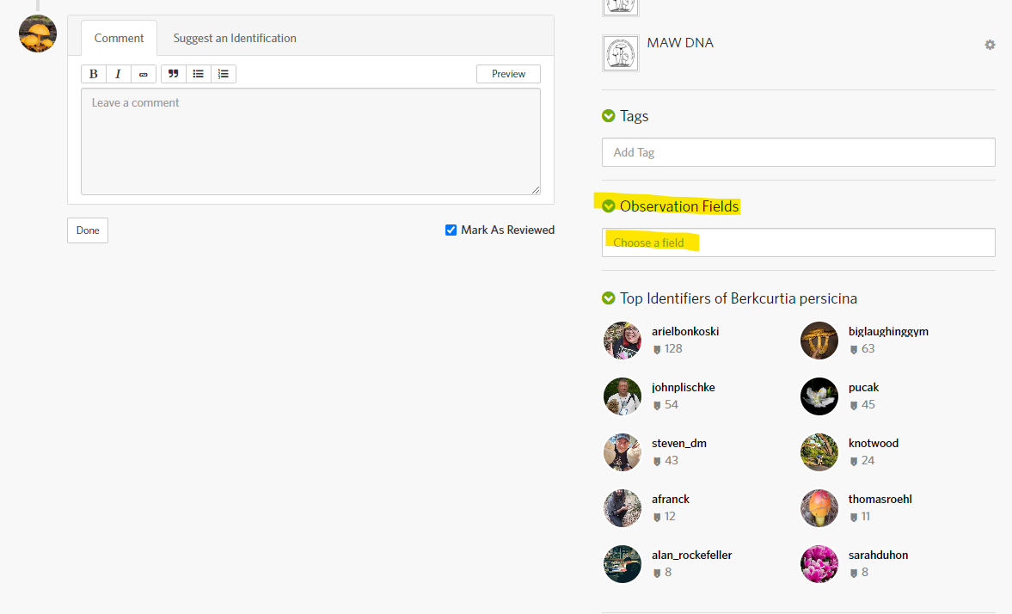
- From the list of options, select “DNA Barcode ITS”
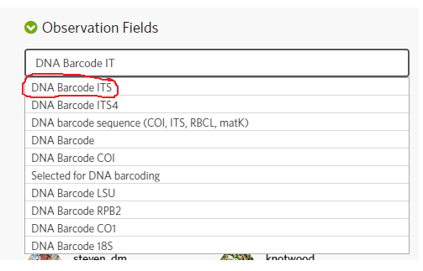

- A textbox will appear. Copy and paste the DNA sequence into the textbox and hit Add.
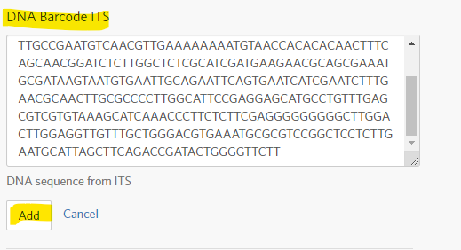

To edit a DNA sequence on an observation:
- Open an observation and scroll down to “Observation Fields” section and click on “DNA Barcode ITS”
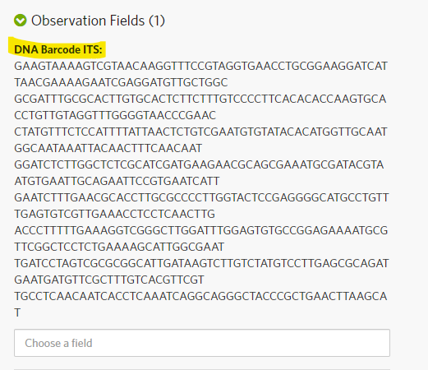

- A pop is displayed, click on the Edit button
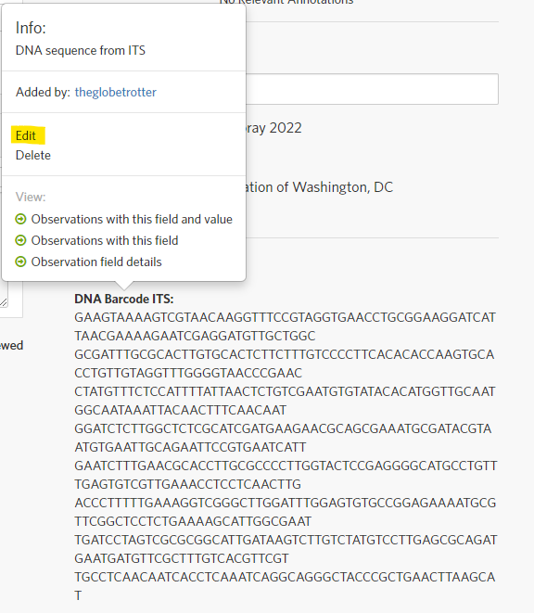
- Edit the sequence and hit Add.
